Chapter 18, Problem 48.

Find i_{o}(t) in the op amp circuit of Fig. 18.50.

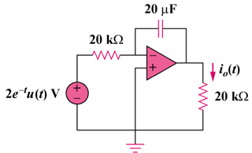

Figure 18.50
For Prob. 18.48.

